Act Argyll Ltd
Improving our environment,
investing in our workforce.

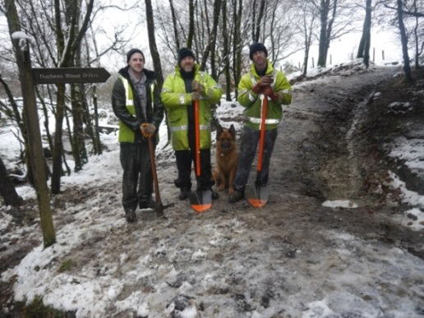

Left: Oban team working at Glencruitten Walled Garden. Right: Helensburgh team working on Glenannan Burn

Act Argyll is an environmental works training company with a focus on improving Argyll’s natural and social environment, and is wholly owned by Argyll and the Isles Coast and Countryside Trust. We were established in August 2015 following a successful bid to the People and Communities Fund (Scottish Government) in partnership with Dunbritton Housing Association. The partnership brings together Act, Forestry Commission Scotland, Argyll and Bute Council, Scottish Natural Heritage, West Highland Housing Association and Dunbritton Housing Association.

We are now up and running and have six trainees on 12-month contracts to carry out environmental improvement works under the supervision of our 2 experienced Chargehands and our Skills and Contracts Manager. We have established Sector Based Work Academies with Job Centre Plus and have Assistants on 8-week paid work experience placements starting February 2016.
Aim
Our aim is to equip our trainees and assistants with the skills and experience they need to move into full-time employment whilst providing our communities with services which enhance our local areas. Not only are we achieving this aim but we are also providing our trainees with an excellent working environment. We have two teams – one in Oban and one in Helensburgh.

“This is the best job that I’ve ever had” – Act Argyll ltd Trainee

Overview
Our one-page business plan (overleaf) details our services, market, key resources, milestones, and activities. Table 1 shows the social impact that we are creating and how it meets the aims and objectives of our partners.
Opportunities
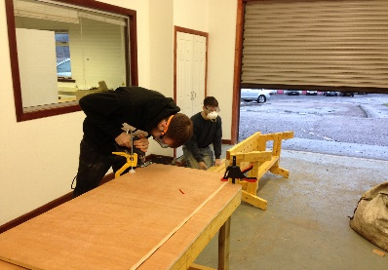
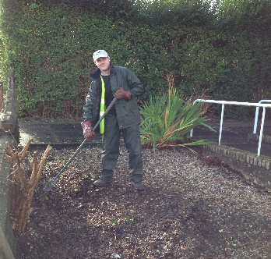

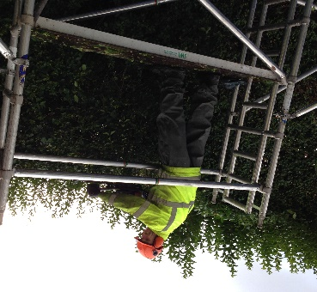
We are currently drawing up a funding package for 2016 including a grant fund applications and seeking additional contract work.
Like to get involved? Call Douglas Grierson, Act Argyll Skills and Contracts Manager, douglas@act-now.org.uk tel: 01546 602755/07824 833001

