  BRANCHING OUT ARGYLL |  | 

Developing Branching Out Argyll, November 2015

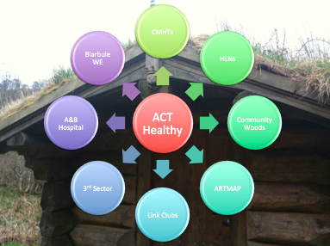
Background
Community Woodlands Association (CWA) was tasked by Argyll & the Isles Coast & Countryside Trust to take forward the development of Branching Out in Argyll. CWA has been integral in establishing Branching Out Highland, working with Abriachan Forest Trust, NHS Highland and FCS to run pilot programmes (2014) and support the development across the area. Early in 2015, ACT approved a scoping paper prepared by CWA to bring Branching Out to Argyll and ACT agreed to be the lead partner in supporting the project for the first 3 years.

ACT being lead partner is a unique set up and lends much strength to the project via the support of its core partners and existing networks.

Work undertaken
In order to develop links with partners, promote the project and secure funding, presentations were made to:
- NHS Mental Health Organisation Group at Argyll & Bute Hospital
- Dunoon Community Mental Health team
- Oban Community Mental Health team
- Mid Argyll Community Mental Health team;
- Mental health occupational therapist group, Lochgilphead
- NHS Highland, Argyll Health & Wellbeing day, Inveraray

A key part of the development work was to secure initial funding. The table below lists applications made and amounts secured.

Fund | £ requested | £ secured
NHS mental health operations group | 2,000 | 2,000
NHS public health services | 8,000 | 8,000
FCS Branching Out | 2,000 | 2,000
Integrated Care Fund OLI | 12,000 | 0
Integrated Care Fund MAKI | 15,000 | 0
Integrated Care Fund Cowal & Bute | 12,000 | 12,000 (in principle)
Integrated Care Fund Helensburgh & Lomond | 12,000 | 0
Mid Argyll Health & Wellbeing Fund | 1,000 | 750
Cowal Health & Wellbeing Fund | 1,708 | 1,708
Oban Health & Wellbeing Fund | 1,708 | Not yet decided
Kintyre Health & Wellbeing Fund | 1,000 | 848
Total funding |  | 25,306

Meetings and discussions were held with ACT partners, the Branching Out Argyll leader, Abriachan Forest Trust, and the FCS Branching Out programme manager to develop an initial programme and leader training.

Building on existing networks and meetings, a database of contacts and resources has now been developed for use by Branching Out leaders and partners.

The funding secured is being spent as follows:
- Branching Out leader training
- Toolkits
- Development and running of programmes at Blarbuie Woods, Lochgilphead and Kilfinan Forest, Tighnabruich

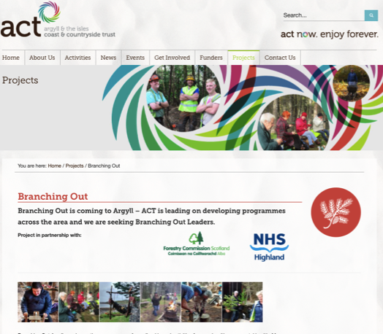
Leader training
Leader training comprises a 3 day specialist course and leaders must also hold Scottish Mental Health First Aid (SMHFA) certificate and an appropriate First Aid qualification. In order to ensure a broad geographical spread across Argyll an application process was launched via the ACT website http://www.act-now.org.uk/en/projects/233-branching-out

A Branching Out leader training course took place at the Argyll & Bute Hospital and Blarbuie Woods, Lochgilphead, 26th – 28th October 2015. Suzann Barr and Roni Smith of Abriachan Forest Trust carried out the training with guest sessions from Dr Grace Ferguson (NHS Argyll & Bute Hospital Principle retired), Yennie van Oostende (NHS Highland Health Improvement Specialist) and Sara Maclean (Branching Out Argyll Leader). Other partners from ACT, CWA and FCS popped by to introduce themselves and meet the course participants. 18 people attended the course bringing the number of leaders across Argyll to 19.

The majority of new leaders still need to attend an SMHFA course and partners at NHS Argyll have agreed to run one especially for Branching Out Argyll – this will take place on 3rd – 4th December in Lochgilphead. ACT has also agreed to organise an outdoor First Aid course for those that do not hold a current qualification and this will take place in the early 2016.

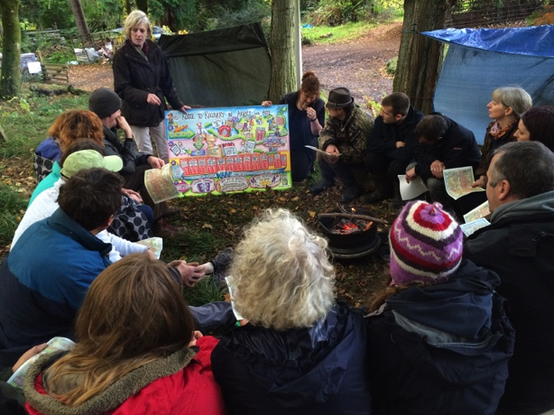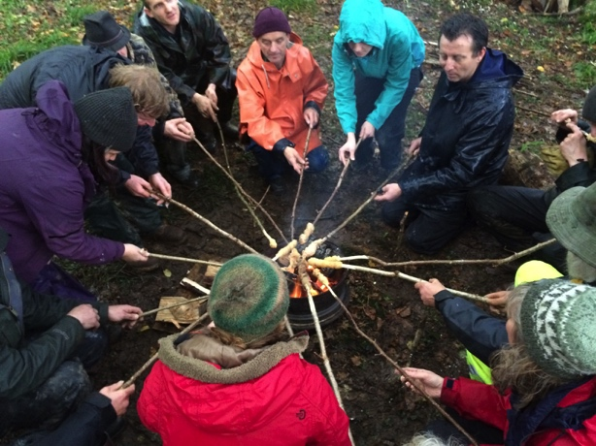

The following people are now trained as leaders:

Area | Name | Associated group (if applicable)
Mull | Lousie Liddell | NW Mull Community Woodland Company
Oban | David O’Brien | NHS Highland Community Mental Health
Oban | Janie Steel | Freelance
Oban | Ross Preston | Freelance/ OWLS
Oban | Melanie Davies | Dunollie Projects Ltd
Mid Argyll/ Loch Awe | Colin Ferguson | Galgael Trust Barmaddy
Mid Argyll/ Loch Awe | Seumus MacKinnon | Galgael Trust Barmaddy
Mid Argyll | Pete Creech | Blarbuie Woodland Enterprise
Mid Argyll | Diane Thomas | Blarbuie Woodland Enterprise/ AGWA
Kintyre | Sheelagh Cameron | Freelance
Kintyre | Helen Chinn | NHS Highland CMHT / freelance
Kintyre | Frank Chinn | Freelance
Islay | Tom Skinner | Islay Community Garden
Cowal | Sara Maclean | KCFC/ CGDT
Cowal | John King | Kilfinan Community Forest Company
Cowal | Mark Bamford | Kilfinan Community Forest Company
Bute | Maria van Oostende | NHS Highland / freelance
Helensburgh/ Lomond | Louise McAllister | Green Aspirations
Helensburgh/ Lomond | Paul Cookson | Green Aspirations

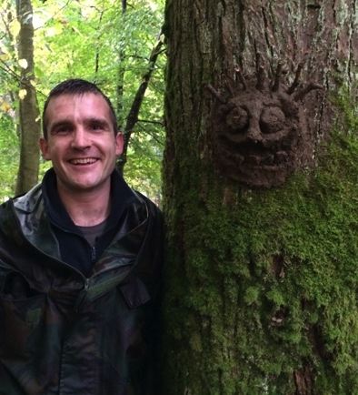

Feedback from the training

Question (5 = excellent - 1 = poor) | 5 | 4 | 3 | 2 | 1
Course objective met | 14 | 4
Trainers’ delivery style | 17 | 1 | 1
Trainers’ understanding of subject | 16 |  | 1
Practical sessions | 15 | 2 | 1
Course handouts | 6 | 9 | 2
Use of visual aids | 10 | 7 | 1
Subject matter discussion | 15 | 1 | 1
Indicate level of understanding of subject prior to course |  | 5 | 7 | 5 | 1
Indicate level of understanding of subject now | 8 | 10
Content was relevant to my job and will make a difference | 13 | 5 | 1
Admin arrangements | 10 | 7 | 1
Venue | 13 | 4 | 1
Overall impression of course | 16 | 3

Comments
- Learnt loads & all very useful within & outwith Branching Out
- Good opportunity to network & share ideas
- Thank you both for a valuable and rewarding three days
- Very good course with real benefits and good outcomes
- Needs to be fully supported by all concerned, Scott Gov, NHS, FCS and all other stakeholders
- Needs to be more widely promoted
- I have found the course enjoyable, useful & informative. It’s been great to network & share experiences with others
- I still feel a bit unsure of how the session planning/ programme will come together.
- Also, I know I need to learn more about safe tool use as this is something I don’t have much experience of
- I really enjoyed the various activities and found it a good way of learning new skills and gaining ideas for new activities
- It was great that everyone had an opportunity to share their skills rather than all of the practical skills coming from one person
- I have learnt a lot of new skills and approaches that I will be able to apply to many aspects of my job, not just branching out!
- Met some very nice people who I will hopefully be able to work together with on future projects.
- How to get the actual rolling our and fund this programme and where it would take place is still quite vague and difficult
- Great course, impossible to pack more in to the time available
- Very experienced trainers, thanks for a great time
- It would have been good not to have travelled to the venue every day but it’s understandable that Lochgilphead was chosen for the location. Maybe I should’ve arranged accommodation to save on the travel/ travel time (1½ hrs each way)
- An excellent course that has really prepared me to moving forward with branching out having covered every aspect to get me started
- Time was tight – could the course be extended for an extra day – I think that would be beneficial
- Many thanks to all involved in organising and presenting this course
- A comprehensive and hugely enjoyable course
- The Branching Out training will compliment the work already taking place at Blarbuie & as well as being a future venue I would hope we could offer places here to folks who have completed the training
- I feel I would have benefitted from a little more info in advance, eg. How the day would be structured & what would be expected of me in leading an activity. I also felt that the activities themselves could have been a little clearer and more structured, not assuming a level of knowledge & assuming that attitudes & comfort levels are shared – having said that, I really enjoyed the course & it has opened new doors for me, thank you!
- I think the mental health first aid course will help provide me with a fuller understanding of some of the issues of branching out

- Really enjoyable course
- Excellent course
- Great trainers in a good venue
- All in all, a great course!
- Lovely soup
- I have had a really enjoyable three days

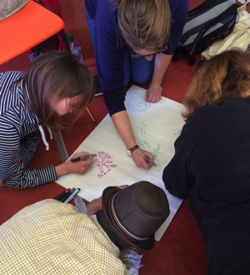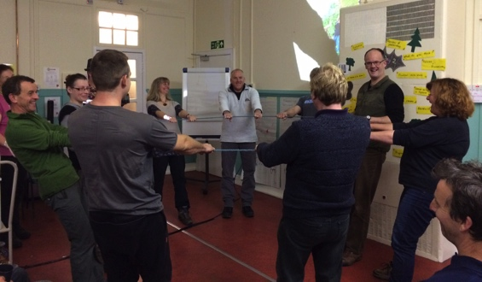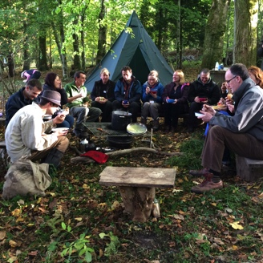

Programme development
The first programme was originally scheduled to run at Stronafian Forest, Glendaruel in partnership with Cowal Community Mental Health Team (CMHT) and Sara Maclean (Branching Out Argyll leader) beginning mid November 2015. It was however, delayed due to unexpected staff shortages at Dunoon CMHT and fresh discussions were started with Mid Argyll CMHT, staff at the Argyll & Bute Hospital and Blarbuie Woodland Enterprise. The Dunoon team are still interested and planning continues with them as well – especially in view of the potential ICF funding. Staff changes at Colintraive & Glendaruel Development Trust have also led to moving the proposed site to Kilfinan Forest. Kilfinan Forest also has a better set up in terms of existing infrastructure, which will help ensure the success of the programme.

The first programme is now scheduled to begin in Blarbuie Woods, Lochgilphead in early February 2016. It will run for 12 weeks and referrals are likely to come from both the Argyll & Bute Hospital and the local community mental health team, which will result in a mix of residential and outpatient participants. The programme will also enable the new ‘trainee’ leaders to undertake their shadowing and complete their training.

Conclusion
Key achievements during this development phase include:
- securing £25k+ funding,
- organising and running Branching Out leader training,
- developing networks and liaising with partners who have all expressed support and willingness to get involved.

Branching Out Argyll, now has leaders ready to develop programmes as and when funding can be secured. ACT is continuing to provide support to leaders and programme development across the area including the first programmes which will run at Blarbuie Woods and Kilfinan Forest. It also continues to seek funding and work to promote the programme.

