ACT’s objectives reflect our area’s social, economic and
environmental priorities

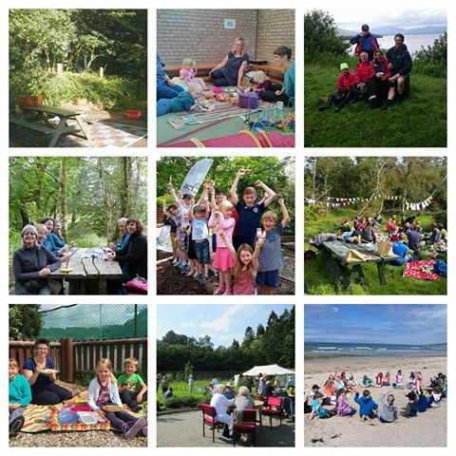
Perfect Picnic campaign entries

Whilst the Scottish Government and the Local Authorities are looking to find savings in their spending they are also aiming to provide better services to communities through community empowerment and local scale initiatives. Act is well positioned to deliver and improve upon services to local communities within our specific remit – environmental stewardship, health and access. Below is a table showing where Act delivers according to the policies that are set out for each of our partners.
Act Objective | Policy Alignment | Partner Agency
To care for and enhance our environment - working strategically and locally.  Projects:  - Act Argyll Ltd.  - Invasive non-native species | SOA  National Outcomes –Wealthier and fairer, Safer and Stronger, Greener | The Scottish Government
 | SOA – 4,5,6  SL – 4  HES - KO3 | Argyll and Bute Council
 | Biodiversity  Access and Health  Community Development – Woods in and around Towns, Working with Communities | FCS
 | Caring for the natural world  Enriching people’s lives  Promoting sustainable economic growth | SNH
 | Healthy Argyll and Bute Partnership – Empowering, Sustaining | NHS Highland
To encourage people to enjoy and benefit from our environment.  Projects:  - Branching Out  - Secret coast trails  - Long distance routes | SOA  The National Walking Strategy  Active Scotland Objectives  National Outcomes – Healthier, Safer and stronger, Greener, Wealthier and Fairer | The Scottish Government
 | SOA – 5,6  SL – 3,4,6  HES – KO1,2,3,6 | Argyll and Bute Council
 | Access and Health  Community Development – Woods for Health, Working with Communities | FCS
 | Enriching people’s lives | SNH
 | JHIP (2013-2016)  Healthy Argyll and Bute Partnership – Empowering, Sustaining, Participative, Effective | NHS Highland
To encourage investment that will improve our environment.  Projects:  - Invasive non-native species  - Act Argyll Ltd | SOA  National Outcomes – Wealthier and fairer, Safer and stronger, Greener | The Scottish Government
 | SOA – 1,3,5,6  HES – KO3 | Argyll and Bute Council
 | Biodiversity  Environmental Quality  Community Development – Working with Communities | FCS
 | Caring for the natural world  Enriching people’s lives | SNH
 | JHIP (2013 – 2016)  Healthy Argyll and Bute Partnership – Empowering, Sustaining | NHS Highland
To share ideas on how to care for, enhance, and enjoy our environment  Projects:  - Secret Coast Trails  - Long Distance Routes | SOA  National Walking Strategy  Active Scotland  National Outcomes – Healthier, Wealthier and fairer | The Scottish Government
 | SOA – 6  SL – 3,4,6  HES – KO1,2,3,6 | Argyll and Bute Council
 | Access and Health  Community Development – Working with Communities, Woods for Health | FCS
 | Caring for the natural world  Enriching people’s lives | SNH
 | Healthy Argyll and Bute Partnership – Empowering, Sustaining, Participative | NHS Highland
To increase opportunities for local people such as work, training and volunteering.  Projects:  - Act Argyll Ltd | SOA  National Outcomes – Wealthier and fairer, Safer and Stronger | The Scottish Government
 | SOA – 1,3,5,6  SL – 4  HES – KO3 | Argyll and Bute Council
 | Access and Health  Community Development – Working with Communities, Woods for Health | FCS
 | Enriching people’s lives  Promoting sustainable economic development | SNH
 | JHIP (2013 – 2016)  Healthy Argyll and Bute Partnership – Empowering, Sustaining | NHS Highland
To work in partnership with individuals or groups with an interest in our environment.  Projects:  - Branching Out  - Secret Coast Trails  - Long Distance Routes | SOA  National Walking Strategy  Active Scotland  National Outcomes – Healthier, Safer and Stronger, Wealthier and fairer | The Scottish Government
 | SOA – 5,6  SL – 3,4,6  HES – KO1,2,3,6 | Argyll and Bute Council
 | Access and Health  Community Development – Woods for Health, Working with Communities | FCS
 | Caring for the natural world  Enriching people’s lives | SNH
 | JHIP (2013 – 2016)  Healthy Argyll and Bute Partnership – Empowering, Sustaining, Participative, Effective | NHS Highland

National Outcomes - http://www.gov.scot/About/Performance/scotPerforms/outcome
Single Outcome Agreement – Community Planning Partnership 2013-2023
Sport and Leisure Framework – Active Scotland National Strategic Priorities 2015 – 2019
Historic Environment Strategy 2014 – Key Objectives
Healthy together Argyll and Bute - http://www.healthytogetherargyllandbute.org.uk/strategic-plan.php
Joint Health Improvement Plan 2013-2016

